

（威海）

Report of Software Architecture

Homework 4.4-1: Mediator Pattern

Basic information
Team name： _______________________________

Class number: ____________________________________________________
Department/school：
Team members with student numbers：

_______________________

Instructor’s comments and score
comments：

score：
signature of the instructor：

Year month date
Homework Description：See the following class diagram for the Mediator pattern implementation of collaboration program for Hotel, Airline and Tour.
HotelGUI
-mdtr TourMediator
+reserveRoom()
+checkIn()
+checkOut()
+notifyAirline()
+notifyTour()
+display()
TourGUI
-mdtr TourMediator
+reserveRoom()
+checkIn()
+checkOut()
+notifyAirline()
+notifyTour()
+display()
BusinessMediator
hotelGui: HotelGUI;
airlineGui: AirlineGUI;
tourGui: TourGUI
+registerHotelGUI(HotelGUI hg)
+registerAirlineGUI(AirlineGUI ag
+registerTourGUI(TourGUI tg)
+updateAllGuis(String text)
AirlineGUI
-mdtr TourMediator
+reserveRoom()
+checkIn()
+checkOut()
+notifyAirline()
+notifyTour()
+display()

The three user interfaces for the Hotel, Airline and Tour are as below.

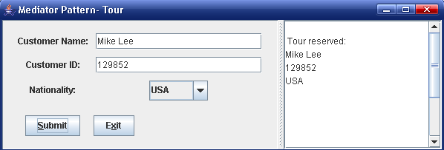
图12.11 旅游公司输入客户信息
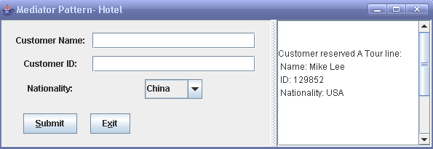
图12.12 宾馆界面同步获得旅游公司输入的客户信息
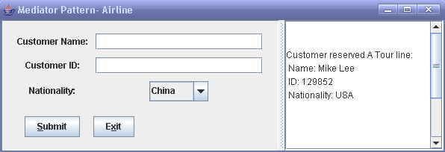
图12.13 机场界面同步获得旅游公司输入的客户信息

Homework requirement:
- Run the program before you go any further
- (Coding) Add another class named TouriststoreGUI such that the 4 classes HotelGUI, AirflightGUI, TourGUI and TouriststoreGUI will interact though the TourMediator in the same way as before (use the mediator pattern).

- Describe your finished homework, including
    - What classes have been added to the existing class hierarchy?
    - The relationship between the existing classes and the newly added classes.
    - What code has been added to what class?
etc.

- Draw the final class diagram here

3. When you enter all the name, id number, and choose the nationality as China, in HotelGUI, what methods in what class have been invoked, list all of them in correct order.

4. Discussion
- Describe the functionality of the TourMediator class.
- Explain how the mediator pattern works?

